**Carbon Emissions of Countries w.r.t World Bank Data**

**By: Arsalan Khan**

**Student No: 21090443**

**Github link:** [**https://github.com/arsal575/ADS1-Assignment2**](https://github.com/arsal575/ADS1-Assignment2)

**Abstract:**

Data is taken from Worldbank to show and compare stats between Pakistan, India, China, Srilanka, Spain, Albania and Bangladesh in carbon emission with respect to Total population, Electricity and Power consumption, Forest Area. This collected data is taken from the World Bank, data source online. From multiple presentations and showing stats of the data by line graph, heatmaps, pie charts etc, I have derived the conclusions. All of those graphs are proven using the matplotlib python bundle. The libraries pandas (it's far used to investigate records), numpy (a python module for managing arrays), and matplotlib (with the aid of the use of python scripts, the matplotlib library permits clients to assemble 2d graphs and plots.).In addition, Seaborn is used to provide a high-level interface for drawing attractive and informative statistical graphics.

**Introduction:**

China has the largest population of any country in the world, with over 1.4 billion people as of 2021. It also has a high level of power consumption and is one of the largest carbon emitters in the world. India is the second most populous country in the world, with over 1.3 billion people. Like China, it has a high level of power consumption and is a significant carbon emitter. Pakistan has a population of around 220 million people and is a significant carbon emitter. Sri Lanka has a population of around 21 million people and is not a major carbon emitter. Bangladesh has a population of around 164 million people and is a significant carbon emitter. Albania has a population of around 2.9 million people and is not a major carbon emitter. Spain has a population of around 47 million people and is a significant carbon emitter.

In terms of total forests, China has around 208 million hectares of forest, India has around 78 million hectares, Pakistan has around 8.5 million hectares, Sri Lanka has around 1.5 million hectares, Bangladesh has around 1.2 million hectares, Albania has around 2.5 million hectares, and Spain has around 17 million hectares.

Table 1: Countries Data Table w.r.t : Population

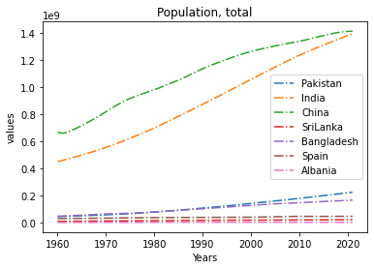

With respect to population, China has the largest population of any country in the world, with over 1.4 billion people. India is second with over 1.3 billion people. Pakistan has a population of around 220 million people. Sri Lanka around 21 million people. Bangladesh with 164 million people. Albania has a population of around 2.9 million people. Spain has a population of around 47 million people..

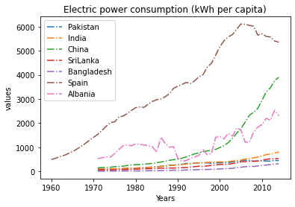

Figure 1: Electric power Consumption(kwh per capita)

Line graph study based on forest area (sq. km) concerning Electric Power Consumption (kwh per capita) from 1960 to 2010. It has been determined that most consumption was in spain and secondly in Alabania in this era but since it has declined and respectively increased in China, India Bangladesh, Pakistan and Srilanka.

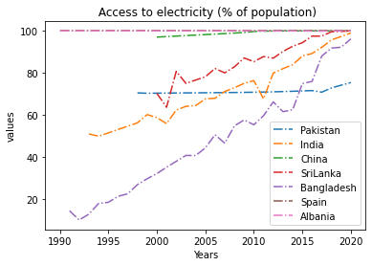

Figure 2: Access to Electricity (% of population)

Line graph study from 1990 to 2020 shows that Electricity access has merely increased in Spain, China and Pakistan. But in India, Srilanka and Bangladesh it has significantly and drastically increased over the years in this era.

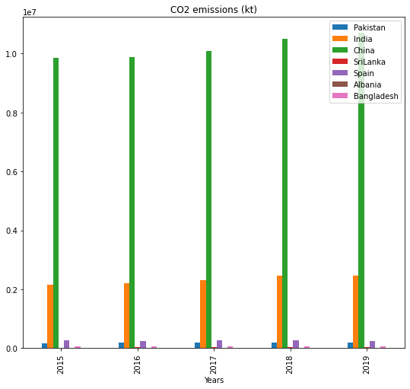

Figure 3: Bar Graph, CO2 Emissions

From 2015 to 2019 the most CO2 emitting country has been china with 4 times more emissions than the second country india and since increasing over the years, then Spain with more emssions w.r.t population. Then Pakistan, Srilanka, Banglandesh and Alabania Respectively.

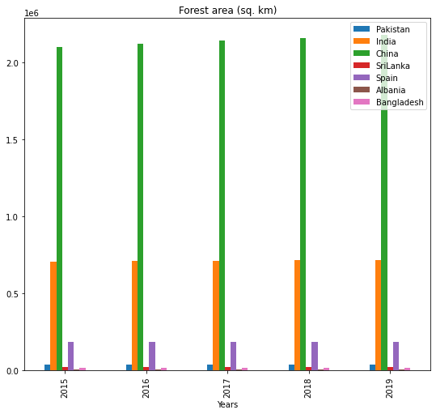

Figure 4: Forest Area per Sq km

This bargraph shows the Forest Area per Sq Km of China, Pakistan, India, Bangladesh, India, Srilanka, Spain and Albania respectively from 2015 to 2019.

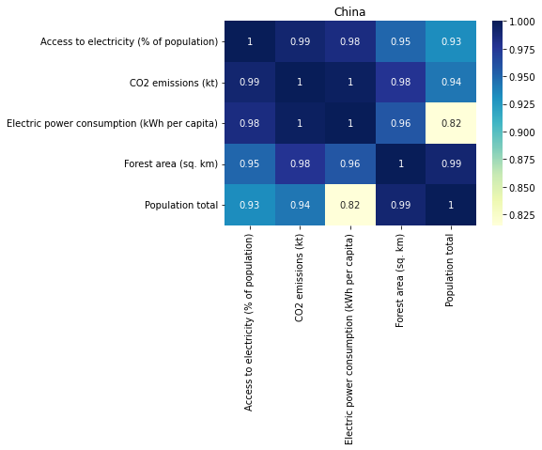

Figure 5: Heatmap Correlation for China

A correlation heatmap of China visualizes relationships between different variables in the dataset. Each cell in the heatmap represents the correlation coefficient between two variables. The color of the cell indicates the strength of the correlation, with darker colors indicating a stronger correlation and lighter colors indicating a weaker correlation such as access to electricity, population and CO2 emissions are strongly correlated whereas Electric Power Consumption to to Total Population is weakly correlated.

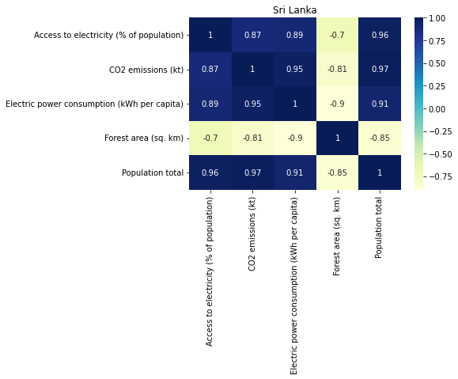

Figure 6: Heatmap Correlation of Srilanka

As we can see from the above Heapmap correlation of Srilanka that CO2 emmissions and total population is strongly correlated and similarly Population and Electricity consumptions are strongly correlated whereas Forest Area and Electric Consumption per capita are weakly correlated, respectively Total Population and Forest Area.

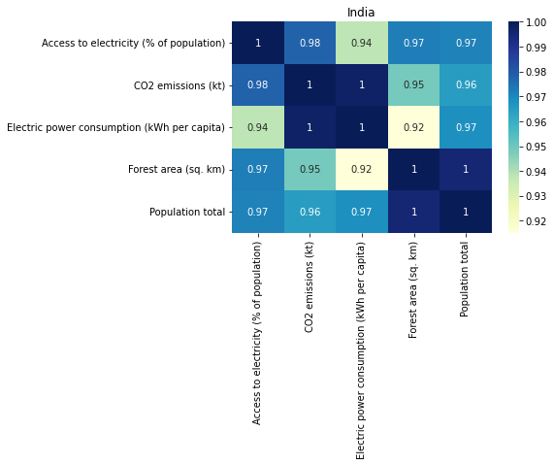

Figure 7: Heatmap Correlation of India

In India CO2 emissions are strongly correlated to Electric Power Consumption per Capita and Forest Area to Total Population. Whereas Forest Area is Weakly correlated to Electric Power Consumption per Capita.

**References**

**Data: World Bank Data**

<https://vitalflux.com/correlation-heatmap-with-seaborn-pandas>